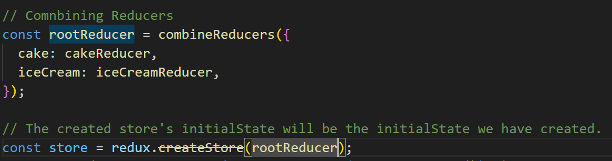
WHAT IS DIFFERENT NOW IS THE OVERALL GLOBAL STATE OBJECT

PREVIOUSLY WE ACCESSED STATE LIKE BELOW:
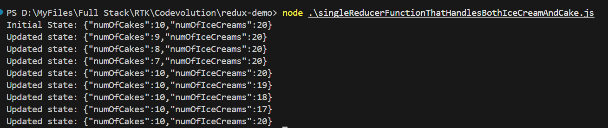
state.numOfCakes

NOW, AFTER COMBINIG REDUCERS, WE HAVE TO ACCESS STATE SLIGHTLY DIFFERENT.
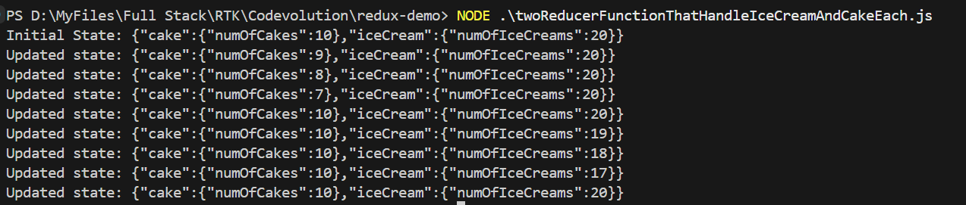

ALSO, WHEN WE DISPATCH AN ACTION, BOTH THE REDUCERS RECEIVE THE ACTION. THE DIFFERENCE IS THAT ONE OF THEM ACTS ON THE ACTION AND THE OTHER ONE IGNORES IT.
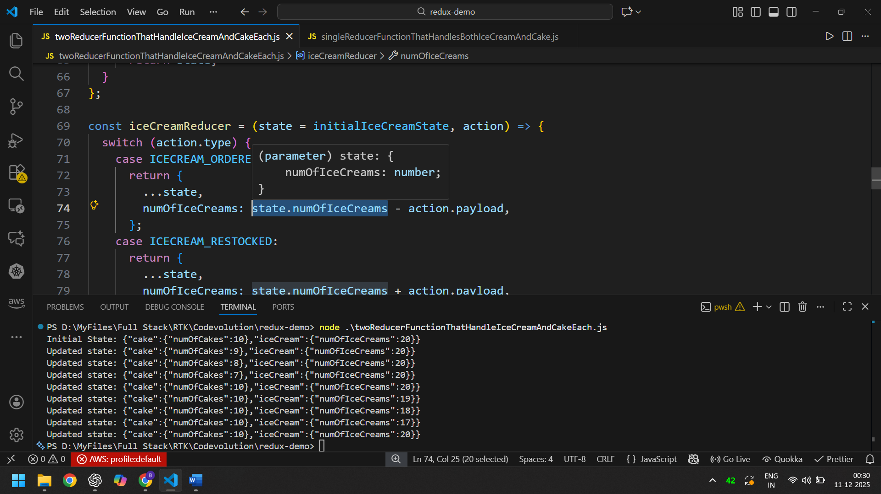
74, look at the question below:
